**[212. Word Search II](https://leetcode.com/problems/word-search-ii/)**

Given an m x n board of characters and a list of strings words, return *all words on the board*.

Each word must be constructed from letters of sequentially adjacent cells, where **adjacent cells** are horizontally or vertically neighboring. The same letter cell may not be used more than once in a word.

**Example 1:**

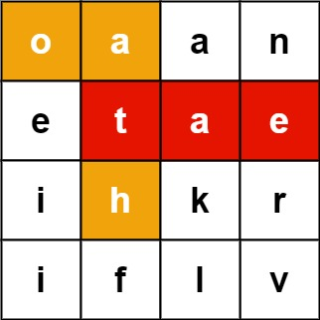

**Input:** board = [["o","a","a","n"],["e","t","a","e"],["i","h","k","r"],["i","f","l","v"]], words = ["oath","pea","eat","rain"]

**Output:** ["eat","oath"]

**Example 2:**

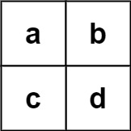

**Input:** board = [["a","b"],["c","d"]], words = ["abcb"]

**Output:** []

**Constraints:**

* m == board.length
* n == board[i].length
* 1 <= m, n <= 12
* board[i][j] is a lowercase English letter.
* 1 <= words.length <= 3 * 104
* 1 <= words[i].length <= 10
* words[i] consists of lowercase English letters.
* All the strings of words are unique.